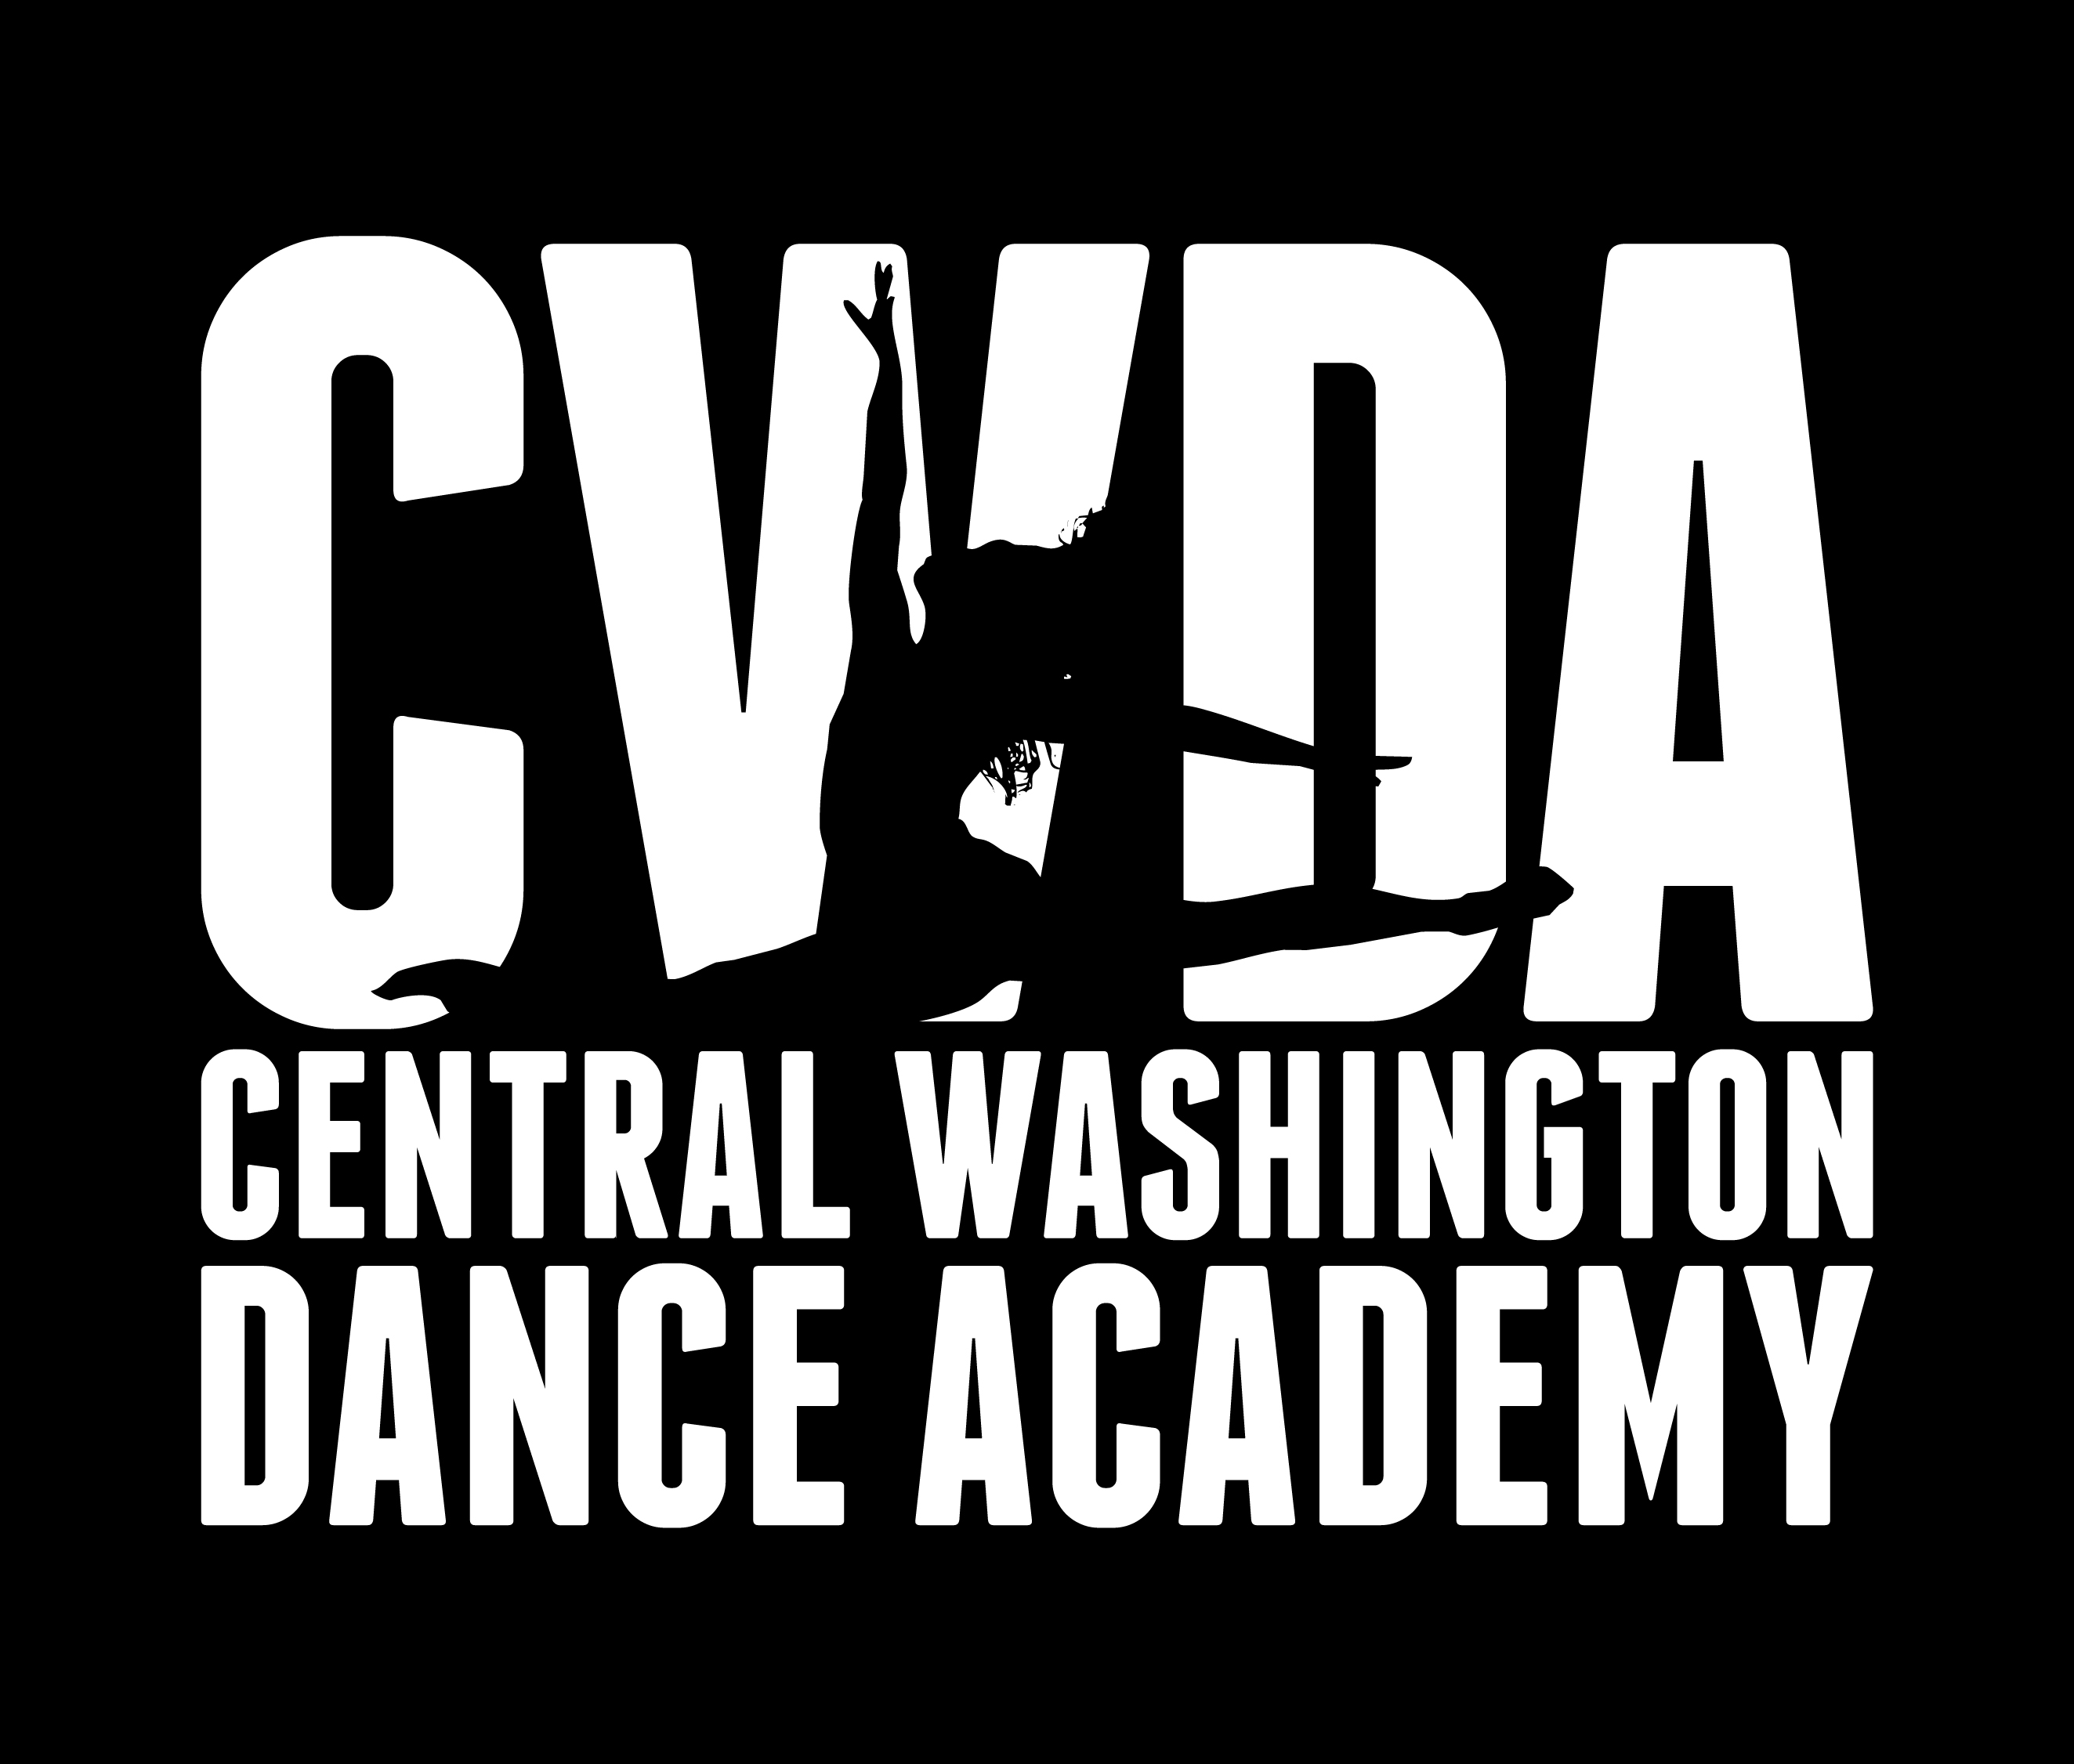
2021-2022 Registration Form
OFFICE USE:
Date:__________________
Pmt. Method:_________
Check #:______________
Quickbooks:__________
Memorized:___________
Email:_________________
Spreadsheet:__________
EFT:_________________

CWDA

DATE:
Dancer:
Date of Birth: Age (as of Sept 1, 2021): __
Allergies/Other Concerns:______________________________________________________________________
CLASS NAME/LEVEL | DAY(S) | TIMES | #HRS/WEEK

PARENTS/GUARDIANS:
Home #: Cell #: Work #: ext.
Mailing Address:
Primary Email:
EMERGENCY INFO. /CONTACT: (Name of relative/friend in case parent/guardian is unavailable).
Name Relationship
Home # Cell # Work # ext.

Method of Payment (Circle One): Cash Credit Check EFT (Same Account) NEW EFT

_____Yes, I give my permission to CWDA to take and use photographs of my child.
_____No, I prefer my child is not photographed and no photos of my child are used.
_____ Yes, I have reviewed CWDA’s rules and regulations in response to Covid-19

CWDA WAIVER AND RELEASE OF LIABILITY:
Every participant and/or legal guardian must read and understand this Waiver and Release of Liability prior to participating in any classes at CWDA.

I hereby agree to assume all risks and responsibility, and to release and hold harmless Central Washington Dance Academy, their employees, sponsors, trainers, coaches, members of the board of directors and affiliated parties (collectively “CWDA”) from any and all claims, actions, causes of action, proceedings, damages, costs, demands, including hospital cost, court costs, and costs on a solicitor and his own client basis, and liabilities of whatever nature or kind arising out of or in any way connected with my/my child’s participation in classes/program(s).

I have read all of the above policies for CWDA and by signing below I agree that I have been informed of these policies for the coming school year.

Signed: ________________________________________ Date: _______________

