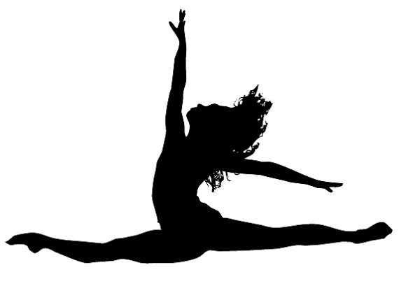
Central Washington Dance Academy
Rules for Re-opening

Please read through carefully. These rules are in place for the safety of our dancers, teachers and staff.
Arrival
- Please take your dancers temperature before sending them to class. If your dancer is showing and symptoms of illness (sore throat, cough, fever) Please keep them home.

- It is the parent’/student’s choice whether they will attend class wearing a mask. It is also the teacher’s choice whether to wear a mask while instructing.

- Once the dancer has entered the studio, they must wash their hands (20 seconds)

- There will be no parents in the lobby before, during or after class.

  - For younger dancers, (ages 6 & under) parents can assist in washing hands before class and must leave the lobby once class begins.
- Students must come already dressed in the appropriate attire and hairstyle. There will be no changing in the dressing room or bathrooms.

- When waiting in the lobby (not the dressing room) dancers must sit in a designated spot. These will be 6ft apart.

- Please bring only what you need, for example shoes. If you take 2 or more classes a week you may use a locker.

  - Lockers will no longer be shared. Staff will reassign lockers of those currently sharing.

- There will be no snacking/ hanging out in the lobby or dressing rooms.

During Class
- Students will remain 6ft apart and keep hands to themselves (Teachers will help facilitate this).

- Make sure students bring their own water bottle. Make sure it has a lid and avoid straws.

- A touchless hand sanitizer dispenser will be provided in the studios. Students must use after leaving the studio and as they see fit throughout the class.

- Teachers will maintain 6ft distance away from dancers only giving verbal corrections.

- Students cannot be picked up early to avoid loitering in the lobby and students waiting outside.

After Class
- Dancers must be picked up promptly after class and parents must wait in car except for students under 6 years of age

- For pick up: dancers will collect their belongings and then check to see if their parents have arrived in their car out front. For those whose parents have not yet arrived, they must wait in the lobby (in a designated spot) Parents who arrive late may open the front door and wave to their child to exit. Older dancers with cell phones may have their parent text them when they have parked. A staff member will be present to help.

Other
- Classrooms, lobby and dressing room vanity will be disinfected before and after each class.
- Touchless Hand sanitizer and soap dispenser will be provided in classrooms and bathrooms.
- There will be 15 minutes in-between each class to facilitate arrivals and departures.
- Floors in dance studios will be mopped down daily and bath rooms cleaned.

CWDA WAIVER AND RELEASE OF LIABILITY:
Every participant and/or legal guardian must read and understand this Waiver and Release of Liability prior to participating in any classes at CWDA.

I have reviewed all rules for reopening of the school and hereby state that I agree to comply with these rules.
I hereby agree to assume all risks and responsibility, and to release and hold harmless Central Washington Dance Academy, its owner, employees, sponsors, trainers and affiliated parties (collectively “CWDA”) from any and all claims, actions, causes of action, proceedings, damages, costs, demands, including hospital cost, court costs, and costs on a solicitor and his own client basis, and liabilities of whatever nature or kind arising out of or in any way connected with my/my child’s participation in classes/program(s).

Dancer Name: _________________________________________________

Parent/Guardian (Printed):________________________________________

Signed: ________________________________________ Date: _______________

